UGANDA MARTYRS UNIVERSITY

COURSE UNIT: EMBEDDED SYSTEM.
KATO JOSEPH BWANIKA
REG: 2023-B291-11709.

ASSIGNMENT ONE: Computerizing a Card Guessing Game Using the Binary Number System
Introduction
Card guessing games are often presented as magic tricks where a person appears to guess a number that someone else is thinking about. However, when examined carefully, these tricks are not magic but are based on logical mathematical principles. The card guessing game provided in this assignment contains several cards with numbers arranged in specific patterns. A person is asked to think of a number between 1 and 31, and by answering a few questions about whether the number appears on certain cards, the guesser is able to determine the exact number.
After analyzing the cards and the provided program code, it becomes clear that the trick is based on the binary number system, which is the same system computers use internally to represent numbers and perform calculations. The arrangement of numbers on the cards follows a logical pattern that corresponds to powers of two. Because of this structure, the number can always be determined by adding the values of specific cards.
This assignment explains the concept behind the card guessing game, how the correct number is determined, how the process can be automated using an algorithm, and how the idea can be implemented in a C program.

Qn1: What is the theory or concept behind this game? How did I arrive at the number you guessed?
From my understanding after studying the card arrangement in the image, the card guessing game works because of the binary representation of numbers. In computing, numbers are commonly represented using the binary system, which uses only two digits: 0 and 1. Every decimal number can be represented as a combination of powers of two.
When examining the cards closely, one important observation is that each card starts with a number that follows a specific pattern:
- First card starts with 1
- Second card starts with 2
- Third card starts with 4
- Fourth card starts with 8
- Fifth card starts with 16
These numbers are all powers of two:
1 = 2⁰
2 = 2¹
4 = 2²
8 = 2³
16 = 2⁴
Using these values, every number between 1 and 31 can be represented as a unique combination of these numbers.
During the game, the player is asked whether their chosen number appears on each card. If the number appears on a card, it means that the value of that card contributes to the final number.
For example, if a person thinks of the number 23, that number can be expressed as:
23 = 16 + 4 + 2 + 1
This means that the number 23 will appear on the cards that start with:
- 1
- 2
- 4
- 16
If the player answers yes to those cards and no to the others, the guesser simply adds those values together:
1 + 2 + 4 + 16 = 23
This is how the correct number is obtained. The trick works because every number between 1 and 31 has a unique binary representation, meaning there is only one possible combination of these powers of two that forms that number.
Therefore, the theory behind the card guessing game is based on the binary number system and the concept of representing numbers as sums of powers of two.

Qn2: How can I automate this process? What is the data and what is the algorithm?
Automation means allowing a computer to perform the guessing process automatically rather than having a person manually calculate the answer. Since the card guessing game already follows a logical sequence of steps, it can easily be turned into a computerized process.
To automate the game, the computer needs certain data.
The main data involved includes:
- The card values: 1, 2, 4, 8, and 16
- The responses from the user indicating whether their number appears on each card
- A variable used to store the total value of the selected cards
An algorithm is a step-by-step set of instructions used to solve a problem. In this case, the algorithm for the card guessing game can be described as follows:
- Ask the user to think of a number between 1 and 31.
- Create a variable to store the total value (sum).
- Display the first card and ask the user whether their number appears on that card.
- If the answer is yes, add the value of that card to the sum.
- Move to the next card and repeat the question.
- Continue the same process for all five cards.
- After checking all the cards, display the final sum.
- The final sum represents the number the user was thinking about.
This algorithm follows the same logical reasoning used in the manual card guessing game. The only difference is that the computer performs the calculations automatically.

Qn3: How can we convey these instructions to a computing machine?
Computers process information using the binary number system, which uses only the digits 0 and 1. Internally, all instructions and data inside a computer are represented in binary form.
Humans, however, normally use the decimal number system, which uses ten digits ranging from 0 to 9. Because binary is difficult for humans to write and understand directly, programmers use programming languages such as C, C++, Java, and C#. These languages allow instructions to be written in a format that is easier for humans to read and understand.
Once a program is written in a programming language, it is translated into machine code using a compiler. The compiler converts the program into binary instructions that the computer can execute.
In this assignment, the card guessing game is implemented using the C programming language. The program follows the algorithm described earlier and asks the user questions about the cards. Depending on the user's responses, the program adds the appropriate values and calculates the final number.
The following C program computerizes the card guessing game:
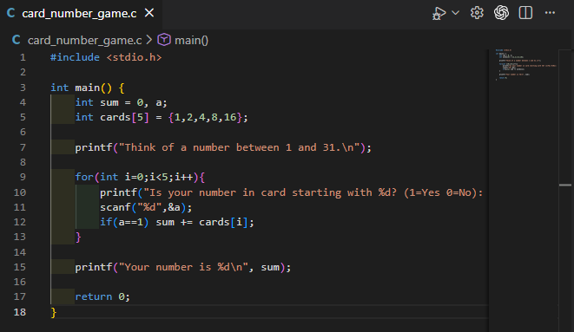
Output:
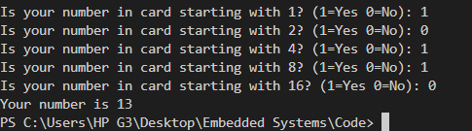
This program stores the card values in an array and uses a loop to ask the user whether their number appears on each card. If the user answers yes, the program adds the corresponding card value to a total. After all cards have been checked, the program prints the final result, which is the number the user originally thought of.

Conclusion
The card guessing game may appear to be a simple magic trick, but it is actually based on the binary number system, which is fundamental to how computers represent and process information. Each card corresponds to a specific power of two, and by identifying which cards contain the chosen number, it becomes possible to reconstruct the number by adding those values together.
By converting the manual guessing process into a structured algorithm, the same logic can be automated using a programming language such as C. This demonstrates how mathematical concepts like binary representation are closely connected to computer programming and problem solving.
Through this assignment, it becomes clear that many activities that appear mysterious or magical can actually be explained using logical reasoning, mathematics, and computing principles.

